
RAMAIAH
Institute of Technology
USN | 1 | M | S

(Autonomous Institute, Affiliated to VTU)
(Approved by AICTE, New Delhi & Govt. of Karnataka) Accredited by NBA & NAAC with ‘A’ Grade

SEMESTER END EXAMINATIONS – JANUARY 2019

Course & Branch | : | B.E. : Common to all branches | Semester | : | I
Subject | : | Engineering Mathematics - I | Max. Marks | : | 100
Subject Code | : | MA11/MAT101 | Duration | : | 3 Hrs

Instructions to the Candidates:
- Answer one full question from each unit.

 |  | UNIT- I
1. | a) | Define Jacobian of 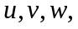 with respect to x,y,z. | CO1 | (02)
 | b) | 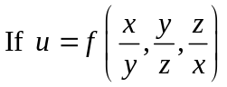, prove that 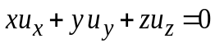. | CO1 | (04)
 | c) | If 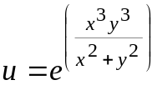 show that 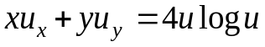. | CO1 | (07)
 | d) | Find the angle of intersection between the following pair of curves: 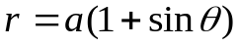 and 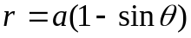. | CO1 | (07)
2. | a) | State Euler’s theorem on homogeneous function of two independent variables. | CO1 | (02)
 | b) | Find the Pedal equation of 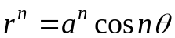. | CO1 | (04)
 | c) | If 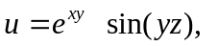where 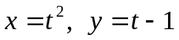, 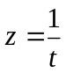 then 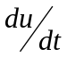at t=1 by partial differentiation. | CO1 | (07)
 | d) | If 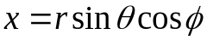, 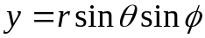, 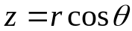 show that 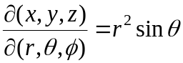. | CO1 | (07)
 |  | UNIT- II
3. | a) | Write the expression to find the area bounded by the cartesian curve. | CO2 | (02)
 | b) | Evaluate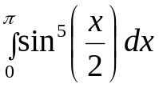. | CO2 | (04)
 | c) | Find the volume of revolution of the astroid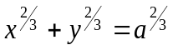, when rotated with respect to x- axis. | CO2 | (07)
 | d) | Trace the curve 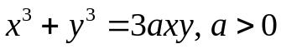. | CO2 | (07)
4. | a) | Write the expression to find the surface area of the solid for a polar curve when rotated about the initial line and the line 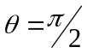. | CO2 | (02)
 | b) | Find the area of the cardioid 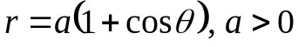. | CO2 | (04)
 | c) | Find the length of one arc of the cycloid: 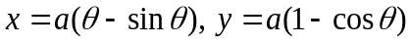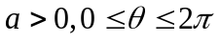. | CO2 | (07)
 | d) | Trace the curve 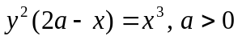. | CO2 | (07)
 |  | UNIT- III
5. | a) | Write the relation between cartesian and spherical polar coordinate systems. | CO3 | (02)
 | b) | Evaluate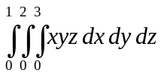. | CO3 | (04)
 | c) | If  is the region bounded by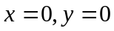 and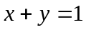 then show by using the transformation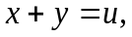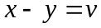 that 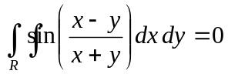. | CO3 | (07)
 | d) | Using double integration, find the area enclosed by the parabolas 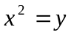 and 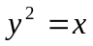. | CO3 | (07)
6. | a) | Convert the integral 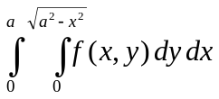 into polar coordinates. | CO3 | (02)
 | b) | Find the limits by changing the order of integration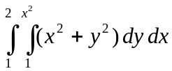. | CO3 | (04)
 | c) | Find the volume of the ellipsoid 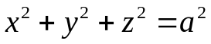 using triple integration. | CO3 | (07)
 | d) | Evaluate 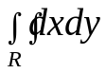where is the region bounded by the curves 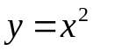and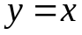. Interpret the answer obtained. | CO3 | (07)
 |  | UNIT- IV
7. | a) | Explain the geometrical meaning of gradient of a scalar field. | CO4 | (02)
 | b) | If 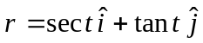 is the position vector of a moving particle then find the velocity and acceleration at 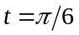. | CO4 | (04)
 | c) | Find the values of the constants 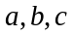 such that is conservative. Also find its scalar potential. | CO4 | (07)
 | d) | Prove that 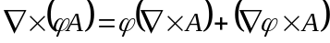 | CO4 | (07)
8. | a) | Define Laplacian operator. | CO4 | (02)
 | b) | Show that 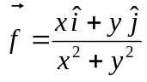is a solenoidal vector. | CO4 | (04)
 | c) | Find the angle between the surfaces: 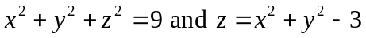at the point 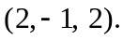 | CO4 | (07)
 | d) | Find the directional derivative of 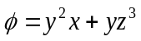 at the point (2,-1, 1) in the direction of the normal to the surface 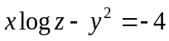 taken at the point (-1,2,1). | CO4 | (07)
 |  | UNIT- V
9. | a) | Give the physical interpretation of 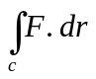, if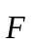is force on a particle moving along . | CO5 | (02)
 | b) | By using Green’s theorem, evaluate 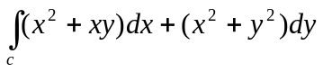 where is the square formed by the lines 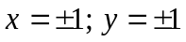. | CO5 | (04)
 | c) | Evaluate 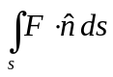 where 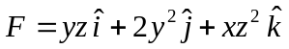 and S is the surface of the cylinder 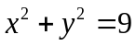contained in the first octant between and 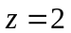using Gauss – divergence theorem. | CO5 | (07)
 | d) | Evaluate 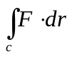 where 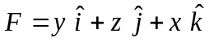where is the boundary of the upper half of the sphere 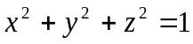 using Stoke’s theorem. | CO5 | (07)
10 | a) | State Gauss – divergence theorem. | CO5 | (02)
 | b) | Find the circulation of 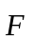 round the curve C where 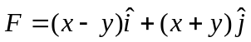 and C is the circle 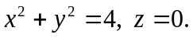 | CO5 | (04)
 | c) | State and prove Green’s theorem in a plane. | CO5 | (07)
 | d) | Evaluate Stoke’s theorem for 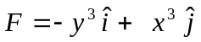where s is the circular disk 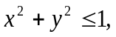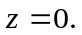 | CO5 | (07)

****************

